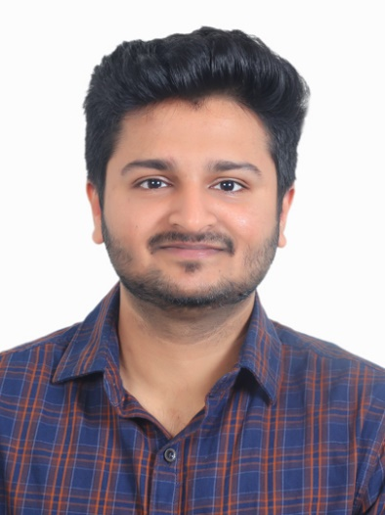

**Darshil Modi**

30/11/98

98000633232

Darshil3011@gmail.com

**۞  Personal Details -**

Birth Place : Ahmedabad

Birth Time : 6:04 A.M.

Cast : Vaishnav (PanchGam Dasha Porwad

Gotra : Kashyap

Zodiac Sign : Pisces (Meen)

Mangalik : No

Height : 5’ 3’’

Weight : 62 KG

Education Details : Masters in computer science

Occupation : Software Engineer

Location : California, U.S.A.

### ۞  Family Background Details -

Father Name : Hiral Bhai Modi

Mother Name : Sejal Ben Modi

Father Occupation : L&D head at Pharmaceutical Company

Sister : Aesha Modi (Study- B.Pharm)

### ۞  Contact Details -

### Contact No. : 8000633232

### Residential Address : 17/Jeshing Park Society, Opp Nelson highschool

### Hirabhai Tower Road, Maninagar

### Ahmedabad - 380008